**Special Problem 02**

**You make it almost impossible to provide any constructive feedback ;-)**

**Outstanding!**

**20/20**

**Question 1**:

Draw a context diagram of a standard kitchen toaster (2 slices, has setting for darkness of toast, pops toast out when done).

**Response**:

The following is a context diagram of a standard kitchen toaster. A few items have been grouped together in boxes – these represent

**CONTEXT DIAGRAM OF STANDARD KITCHEN TOASTER**

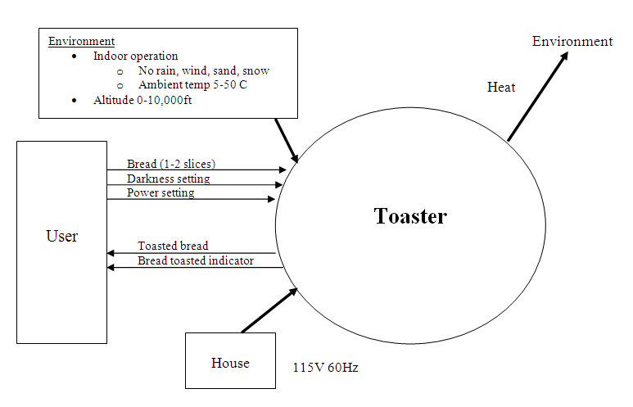

**Question 2**:

Provide a function list of the toaster**.**

**Response**:

Based on the description provided with the definition of the standard kitchen toaster, the following is a function list of this common household appliance:

* Accept bread (1-2 slices)
  + Input bread
  + Store bread
* Accept darkness setting
  + Accept user input
* Accept power setting
  + Turn electricity (internal circuitry) on/off
* Produce heat
  + Convert electricity to heat
* Toast bread
  + Heat bread
* Eject bread when toasted
  + Sense darkness of toast
  + Eject bread for user

**Question 3**:

Draw a functional block diagram of the toaster (hand drawn is acceptable).

**Response**:

Using the same concept developed when formulating the context diagram, the following is a functional block diagram of the toaster. Note that all functional blocks start as a result of user input, and end back at the same interface.

**FUNCTIONAL BLOCK DIAGRAM OF STANDARD KITCHEN TOASTER**

